DAY-7 Live Deployment

And Post-Launch Practices

Environmental Variables added in Vercel.

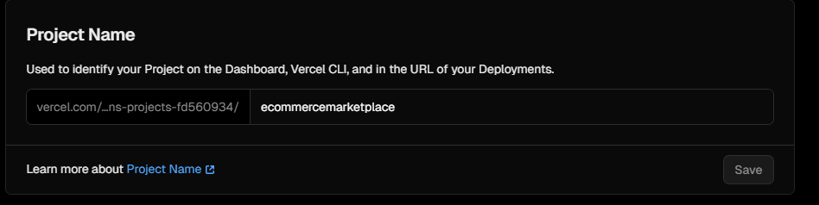

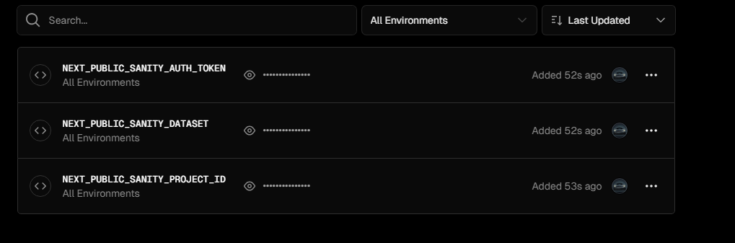

HTTPS



Analytics Tool



